CSA0604 – DESIGN AND ANALYSIS OF ALGORITHM
LAB PROGRAMS
SESSION 2
NAME:ABZAM.A
REG NO : 192573029

1. Find Unique Elements
Code
#include <stdio.h>
int main() {
int arr[100], unique[100];
int n, i, j, count = 0;
int found;
printf("Enter the number of elements: ");
scanf("%d", &n);
if (n < 0 || n > 100) {
printf("Invalid number of elements\n");
return 1;
}
printf("Enter the elements:\n");
for (i = 0; i < n; i++) {
scanf("%d", &arr[i]);
}
for (i = 0; i < n; i++) {
found = 0;
for (j = 0; j < count; j++) {
if (arr[i] == unique[j]) {
found = 1;
break;
}
}
if (found == 0) {
unique[count] = arr[i];
count++;
}
}
printf("Unique elements: ");
for (i = 0; i < count; i++) {
printf("%d ", unique[i]);
}
printf("\n");
return 0;
}

Output
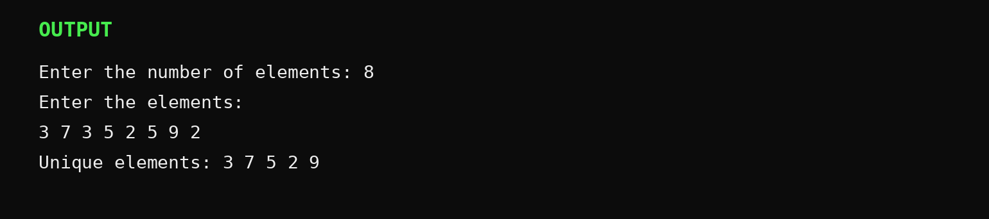
Space Complexity: O(n)

2. Bubble Sort
Code
#include <stdio.h>
int main() {
int arr[100];
int n, i, j, temp;
int swapped;
printf("Enter the number of elements: ");
scanf("%d", &n);
if (n < 0 || n > 100) {
printf("Invalid number of elements\n");
return 1;
}
printf("Enter the elements:\n");
for (i = 0; i < n; i++) {
scanf("%d", &arr[i]);
}
for (i = 0; i < n - 1; i++) {
swapped = 0;
for (j = 0; j < n - i - 1; j++) {
if (arr[j] > arr[j + 1]) {
temp = arr[j];
arr[j] = arr[j + 1];
arr[j + 1] = temp;
swapped = 1;
}
}
if (swapped == 0)
break;
}
printf("Sorted array: ");
for (i = 0; i < n; i++) {
printf("%d ", arr[i]);
}
printf("\n");
return 0;
}

Output
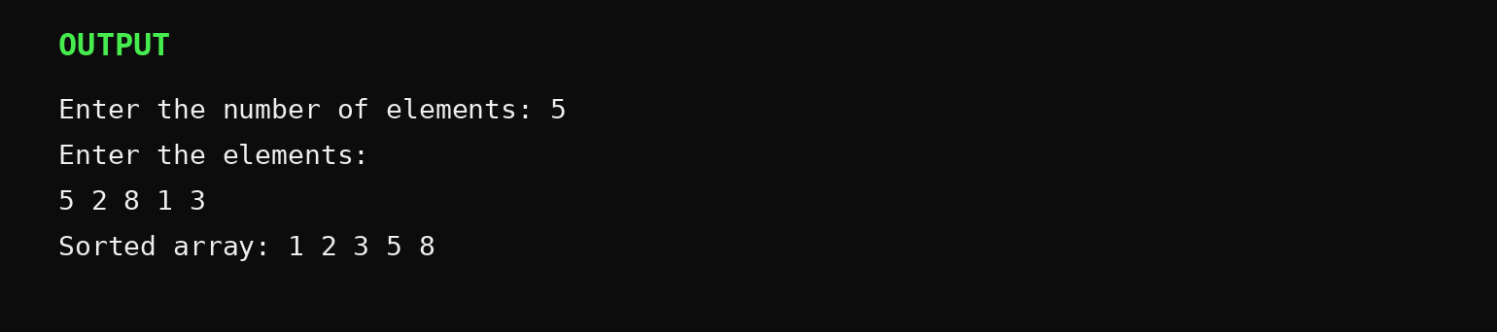
Best Case: O(n) Average Case: O(n²) Worst Case: O(n²) Space Complexity: O(1)

3. Binary Search
Code
#include <stdio.h>
int main() {
int arr[100];
int n, key;
int low, high, mid;
int found = 0;
printf("Enter the number of elements: ");
scanf("%d", &n);
if (n < 0 || n > 100) {
printf("Invalid number of elements\n");
return 1;
}
printf("Enter the elements in sorted order:\n");
for (int i = 0; i < n; i++) {
scanf("%d", &arr[i]);
}
printf("Enter the element to search: ");
scanf("%d", &key);
low = 0;
high = n - 1;
while (low <= high) {
mid = low + (high - low) / 2;
if (arr[mid] == key) {
printf("Element %d is found at position %d\n", key, mid + 1);
found = 1;
break;
} else if (arr[mid] < key) {
low = mid + 1;
} else {
high = mid - 1;
}
}
if (found == 0) {
printf("Element %d is not found\n", key);
}
return 0;
}

Output
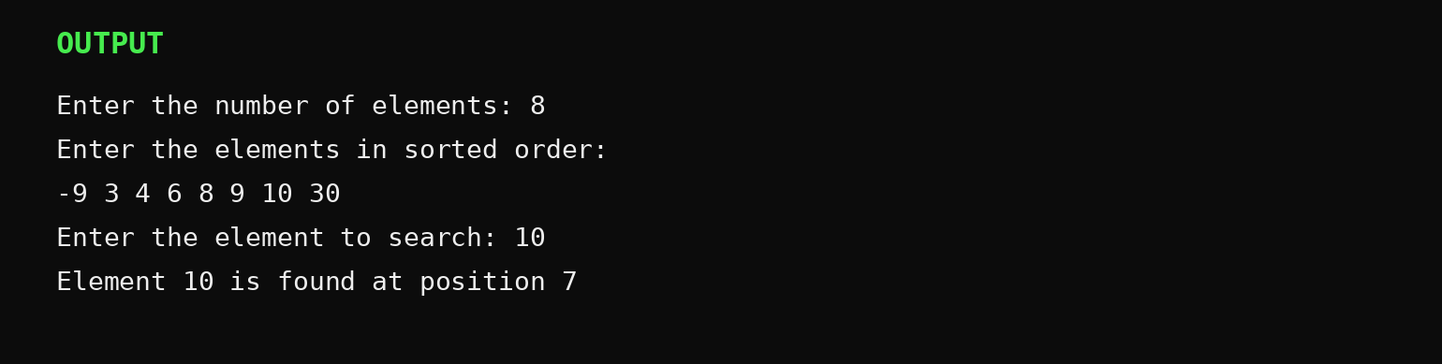
Time Complexity: O(log n) Space Complexity: O(1)

4. Sort Array Using Heap Sort
Code
#include <stdio.h>
void heapify(int arr[], int n, int i) {
int largest, left, right, temp;
while (1) {
largest = i;
left = 2 * i + 1;
right = 2 * i + 2;
if (left < n && arr[left] > arr[largest])
largest = left;
if (right < n && arr[right] > arr[largest])
largest = right;
if (largest == i)
break;
temp = arr[i];
arr[i] = arr[largest];
arr[largest] = temp;
i = largest;
}
}
void heapSort(int arr[], int n) {
int i, temp;
for (i = n / 2 - 1; i >= 0; i--)
heapify(arr, n, i);
for (i = n - 1; i > 0; i--) {
temp = arr[0];
arr[0] = arr[i];
arr[i] = temp;
heapify(arr, i, 0);
}
}
int main() {
int arr[100];
int n, i;
printf("Enter the number of elements: ");
scanf("%d", &n);
if (n < 0 || n > 100) {
printf("Invalid number of elements\n");
return 1;
}
printf("Enter the elements:\n");
for (i = 0; i < n; i++)
scanf("%d", &arr[i]);
heapSort(arr, n);
printf("Sorted array: ");
for (i = 0; i < n; i++)
printf("%d ", arr[i]);
printf("\n");
return 0;
}

Output
Time Complexity: O(n log n) Space Complexity: O(1)

